Author's note: The actual inspiration for Will comes from my times in high school and college when I wanted to quickly drop into tabletop role playing games or pick up a new RPG video game without spending hours trying to invent a unique character. I also liked the idea of placing myself into fan-fiction stories of other universes. Once I had the idea of “myself, but able to go anywhere and blend in” I had to reverse engineer a backstory for how a person might become like that and a “dimension jumping Pretender” story was born (remember that show from the 90s?).

William Davenport
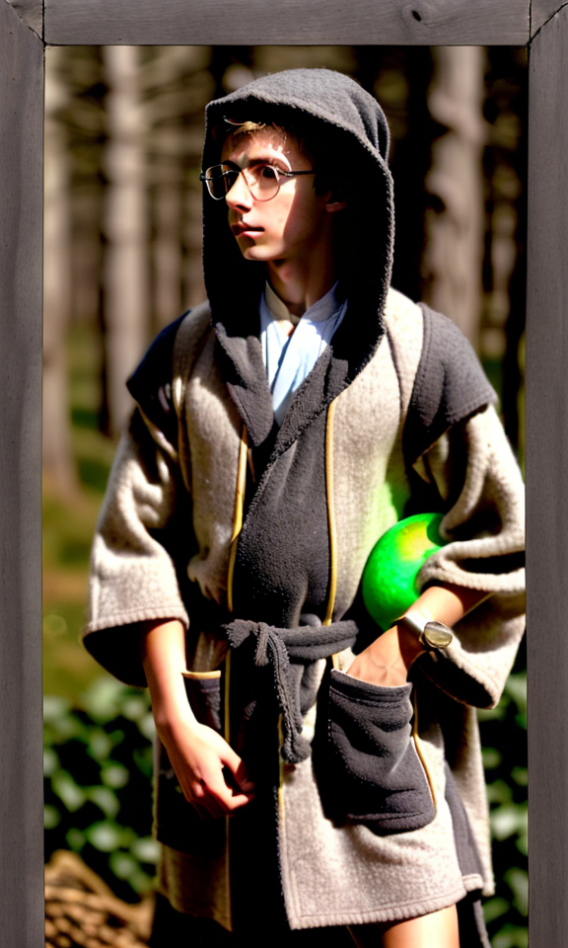
William Davenport is the main character of the Will Story (working title). He's a young adult in his early 20s who begins the story as a magi-apprentice at the magic academy on Myrah, the grey world. He's from a non-magi family but he shows a lot of magical aptitude. Given that, he was taken from his family at a very young age (around 4 or 5) to attend the academy and move into the elite class that runs their society. Although his parents are merely a shadow in his memories, he still remembers their unconditional love and determination to make every day better than the last.
Although he is one of the top students academically, he's always struggled to fit into the rigid structure and strict rules of their authoritarian society (imagine living in North Korea). Even though he no longer remembers his home and family, he still misses his home, his family, and the freedom he knows exists outside the walls and magic bubbles that protect the cities.
As a creative outlet, William took up painting in secret. He found access to a private courtyard between the academy buildings where nature tried to push through the gravel and haze. He would often sneak off to the courtyard to paint and be by himself. It was on one of these divergences when he found it: the gemstone that would allow him to harness enough energy to leap away from Myra and begin his adventure.
Given Will's sheltered upbringing (literally never leaving the academy), he is completely naive to the world and how most societies operate. He has little experience with money, the environment, or common social customs. His interpersonal communications were always amongst a closed group that was seeking information to use for backstabbing and one-upping (something Will does not like to participate in, but must protect himself from).
Although naive, he's intensely curious and enjoys learning about new people, new magicks, and new technology. He has confidence in his ability from his mastery of even the hardest classes at the academy. He knows that, given enough time, he can learn almost anything. Every challenge is simply another learning opportunity.

As he progresses, Will meets Julia as well as discovers multi-dimensional versions of characters with a variety of backgrounds and dispositions. He'll learn over the course of the story that a person's unique situation isn't just driven by fate, but instead by the culture they are raised in. He'll eventually becomes nostalgic for his home and guilty that he's able to see freedom while so many of his compatriots are still stuck in an oppressive home. This pressures him to return and try to fix his homeworld's society.
In the current draft, Will will eventually meet Julie, who herself is a powerful sorceress dictator from another dimensional world. It's actually Julie who's been calling him across the void. She is a 'devouring mother' archtype and needs Will's goodness and magical ability to increase her own power and further subjugate her world. It turns out that Will, Julie, Julia, and another character (Marcus) are all the same 'person' or 'soul' but are each completely unique people with different attitudes. Will not only comes to realize that people are shaped by their environments, but also that all of these people live inside him and his ultimate conquering of Julie and Myrah require that he integrate these different sides of himself.

William's Staff
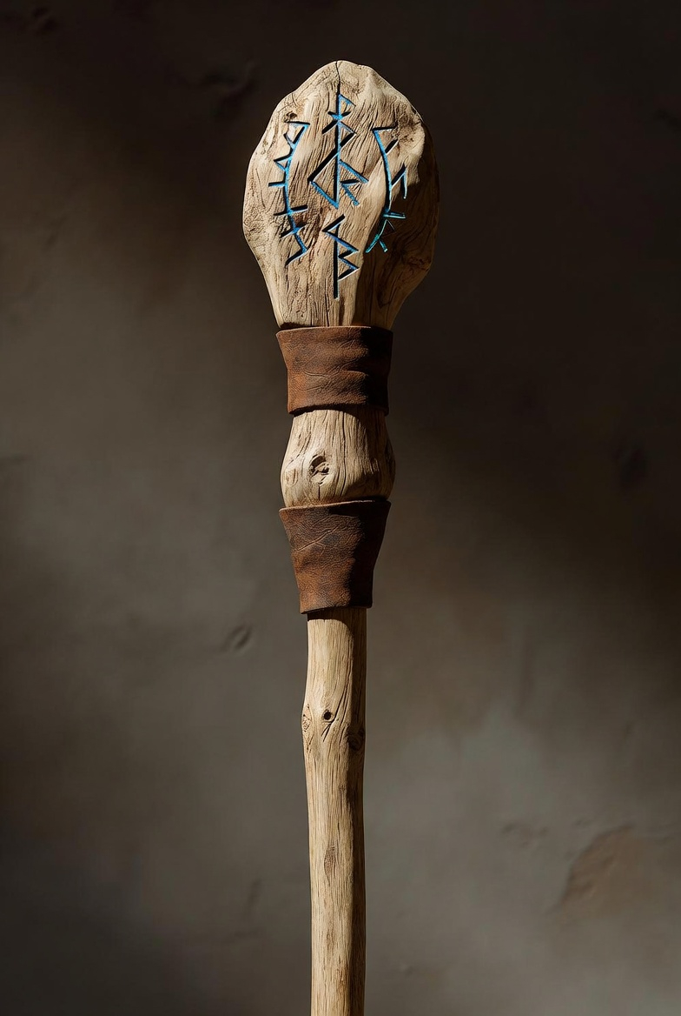
Note the image is a draft for inspiration only.
William’s staff is a practical, three-section modular quarterstaff around 5 feet in length, crafted primarily from lightweight, flexible willow and designed to serve as both arcane focus and combat tool for a third-rank Myrah magi. It consists of a knobby head, a main shaft, and a reinforced foot, joined at reinforced connection points wrapped in slightly protruding leather grips for secure handling during incantations, shielding, or defensive swings. The head bears Will’s own hand-hewn runes—etched after several painstaking attempts to optimize arcana flow—while the entire length is scuffed and scarred from years of academy drills. This utilitarian design is a reliable, repairable conduit for lightning orbs, wind barriers, or dimensional jumps.

Will’s Arcana: Personal Manifestations
Will’s command of Arcana is highly individualized, blending elemental orbs, mythic constructs, god-tier techniques, artifacts, and meditative disciplines. His system emphasizes flexibility, personal shields, fusion effects, and mental clarity. The following catalog is drawn directly from the ghostwriter’s recovered pages.

Foundational / Myrah
- Orb/Lightning (Light) – Pure illumination or directed lightning strikes.
- Barrier/Deflection (Wind) – Creates a personal wind shield whose size can be scaled to the wielder’s needs.
- Healing (Light) – Restorative light energy that mends wounds and fatigue.
- Walling (Earth) – Raises durable earthen barriers or fortifications.
- Shower Sparks (Fire) – Releases a burst of sparks that detonate on impact (noted with high-voltage or explosive potential).
- Fireball (Fire) – Concentrated fiery projectile; variants show fusion potential with other elements.
- Jump – Myrah → Mist → Geb → Alt… – A signature translocation technique to move between dimensions. By entering a semi-meditative state, Will can form a crack between worlds and push himself through.

Ged
- Pin-point Deflection (Mirror Point – Anti-Magic) – Precision deflection that can neutralize or reflect incoming spells by creating momentary mirror-like focal points.
- Pin-point Bolts – Seeking projectiles cast at extreme speed; they home in on targets with minimal wind-up.
- Monster King – Foresight: Clarity of Mind – Grants perfect mental clarity, enhanced foresight, and control over jumps or spatial manipulations.

Alt World
- Prime Prismatic Focus / Stress Crystal (Light) – An alternative light-based enhancer that uses crystalline structures to split, amplify, or refract energy for complex multi-effect casting.
- Spell-Blade (Artifact – Electric / Fusion) – A bladed weapon charged with Arcana. Base form is a light-blade; it can fuse into a fire/light hybrid (electric properties) for devastating close-range combat.
- Lightning → Flesh Bond / Bang – An emerging technique that channels lightning directly into biological or explosive flesh-based effects (still under refinement).
- Vibrational Depth Finder – Rencantus – A sensory tool that detects hidden structures, depths, or presences through vibrational resonance.
- Compass – Arcana-guided navigation aid.
- Camp-Fire Striker – Rune – A simple yet reliable runic tool for instant, controlled fire-starting.
Will’s Arcana is not static. It evolves through meditation, artifact integration, elemental fusion, and deliberate acts of willpower. The system rewards creativity and discovery—exactly as the philosophical core demands. In the dystopian academy of Myrah, where the Grand Magi Council teaches only “Controlled Void” theory for collective obedience, Will’s personal path stands as a radical assertion of individual life-force and limitless potential.

© 2018-2026 Marcus Davenport. See Site_Notice for licensing info.

