William's Story: Shatter The World
This is the story of Will - a teenager who was taken from his home at an early age to live a life of relative ease, but never quite fitting into that life and ultimately fighting to destroy the aristocracy.
–
The Void–
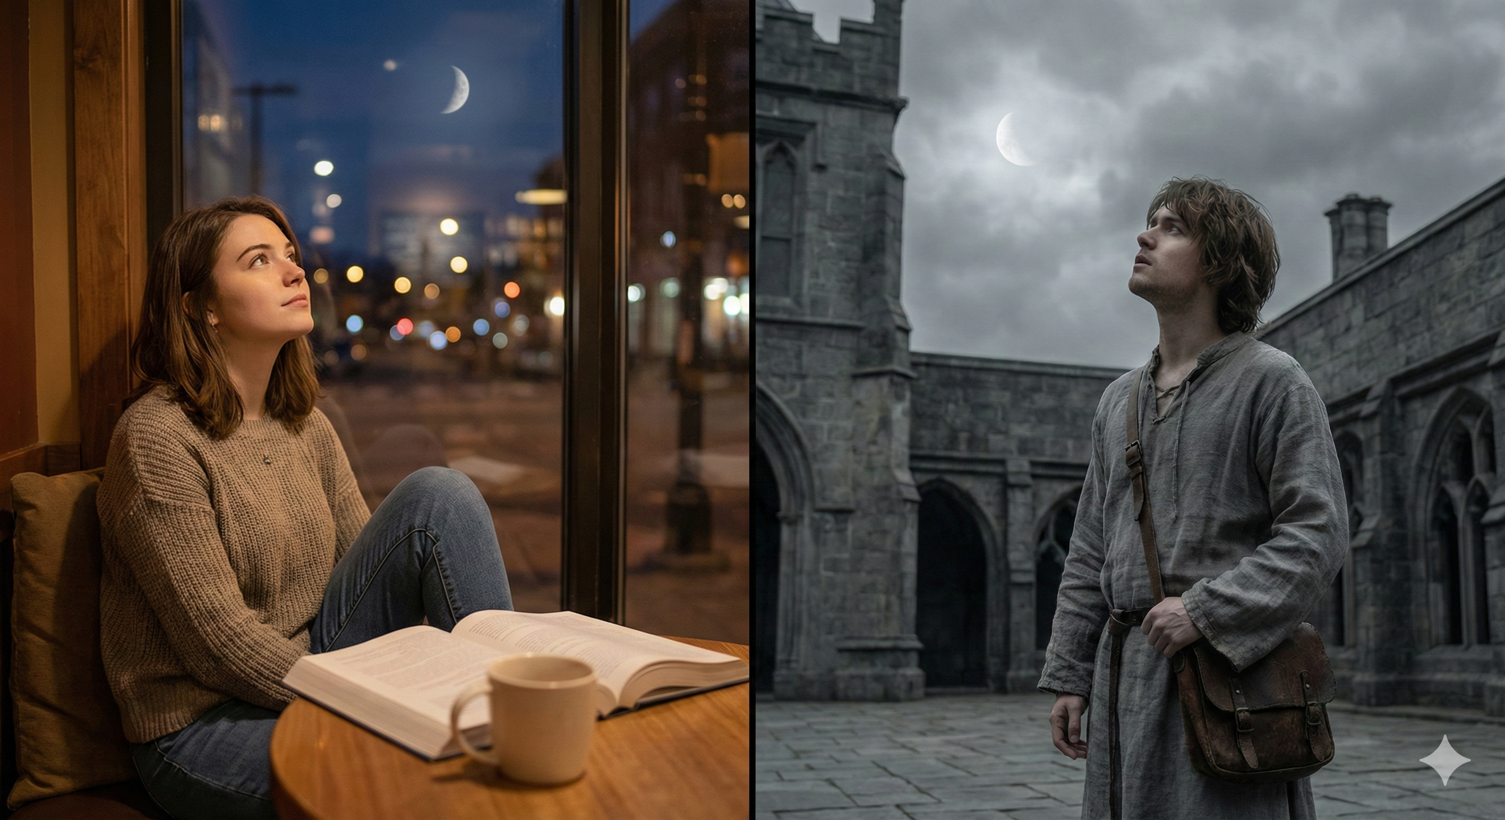
will_s-story-short.mp3
Begin Chapter 1…

Table of Contents
NOTICE© 2018-2026 Marcus Davenport. See Site_Notice for licensing info.

