Chapter 1: The Grey World
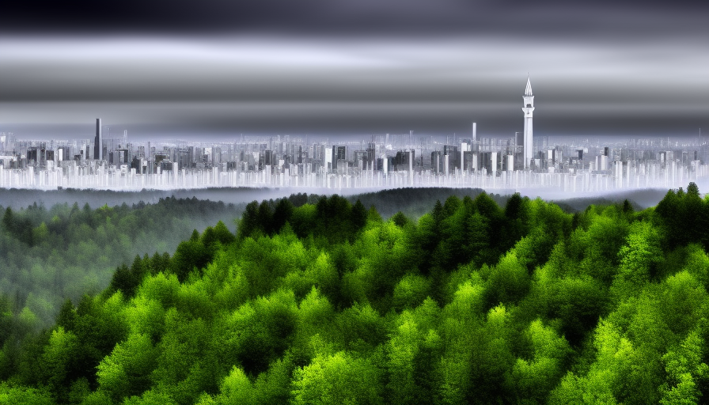
The dream is always the same way.
You float in a void]; a place that has no edges. In one moment, you're standing on a sunlit street lined with plants so impossibly green they hurt to look at. Cars hum past and children laughing in the background; the air is sweet with cut grass and distant rain. In the next moment, the ground dissolves beneath your boots and you tumble through a place of vivid energy: your mind fills with the images of floating crystal spires that sing in frequencies no human ear should hear, with rivers of liquid starlight and abstract animal shapes flying overhead with wings made of pure spell-light. Then the colors bleed away, sucked into a black that had no bottom. Back into The Void. No sound, no direction, only raw emotion. This is what a world of magic is like: white-hot threads whip past like silent lightning, burning without heat, and the lightest touch overpowers you with feelings of joy so extreme you might burst into tears; elsewhere, strands of dark energy float past and getting close seem to bring you back down into an emotional chasm that makes your sternum feel like it's being ripped open. And always, at the center of the storm, she waits. The girl... Grey mist coils around her like perpetual smog. Black shadows cling to her edges in a way that devours every detail, swallowing her face, her hands, the color of her eyes. You never quite see her. But her voice cut through the chaos as clear as a struck bell. “William… William… I need you. Find me, please…” The plea followed you through every shift of the dream. When the sun warms your skin in one heartbeat, her voice is there. When magic lifts you weightlessly in the next, her voice is there. When the Void swallows you whole, her voice is there. It gets closer as the dream goes. It's desperate, as though the darkness itself is trying to choke it out. “William… I need you. Find me…” You reach for her every time. Your fingers pass through mist and shadow but came away empty. The dream has been repeating for months—every night, sharper, louder, more urgent—until the words feel like they've carved into the inside of your skull. And then, the propaganda voice bleeds through, the way it always does every morning. “Citizens of Myrah! The Revolution continues today!” From above, the world of [[Myrah looked much like any other world. Rivers, mountains, forests, and, of course, cities. Cities that covered roughly half of the arable land of Myra.
It hadn't always been like this - as Will called it, “a grey world”. Long before it had been a world that was wild and free of this gloom. It was in those days still a very young world.
Until the Arcanian Revolution, the world had long been home to what most people refer to as 'magic'. Those special powers were latent in nearly a third of the world's inhabitants and during the ages of antiquity had shaped many of the earlier kingdoms as empires.
As wars consumed the world in those older days, a small cabal of the magical elite began meeting with the other like-minded elites in the surrounding kingdoms.
Though a minority of the world's populace, these gifted families of magi landed upon a solution to the endless bickering and suffering of the common people. They formed a ruling aristocracy that would pull a single country into control of the entire world. Though at first it was intended for good, as time passed, power did what power does to great men and women across all times.
That had all been over a thousand years ago. All of those great families had since collapsed, corrupted, or been abolished over the spanning centuries. In fact, from Will's perspective, it was all so pointless. He hadn't been born into any of that. For all he had known was that his parents were of non-magi lineage, which meant he was only slightly more important than those who hadn't been gifted the magical talents.
People without magical aptitudes still lived in every corner of the world, but they all, in one way or another, paid homage to the magical elites and their grip on power.
There had, of course, been revolts. The details of which were unpleasant, to say the least. A few thousand or so repressed workers would rally for action, they would damage property, try to assault magi-elites in their homes, but were met with the inevitably response.
Few knew the horrible details, but those who weren't killed in the streets were arrested, tortured, and anybody associated with the uprising would be executed or exiled to the Trans-Herridan Wall - a virtual death sentence.
Will had always hated the system, but knew better than to voice his thoughts. That would have been dangerous. Instead, he simply kept his head down and tried to remain as harmless a person as possible. His studies helped in that; most hardly paid much heed to a non-elite magi, even if he was one of their most talented.
That was how all of this stood on the day before he found 'it'; something that would change Will's entire perception of the world and his life.
The night before there had been a fire shower in the Eastern Sky. It was common - usually space dust impacting on a city-wide barrier or discharges from the many generators that provided power to the cities.
Next day routines were like normal. He woke at dawn for practices, went through his morning inspections, went to classes, had lunch, and then the daily exams. Not much changed on the whole. His academy was surrounded by a meter thick 'wall' to keep non-magi out. New students were transferred from other academies, while others were sent closer to the main nexus in the capitol city, Thallius.
It was during his lunch that he chanced a quick walk around the ground. The ground felt good under his feet after the past several hours of standing and sitting on solid stone floors.
He might have missed it completely if there hadn't been just the slightest shift in the wind and sunlight that day. It was no bigger than his thumb; smooth and round in a way that there was a small scoop missing in the bottom center with specks of jet black speckled over the mostly turquoise surface.
The moment Will touched it; that was when everything changed forever…
Continue to chapter 2…

